Guidance Notes

Central Milton Keynes - residents

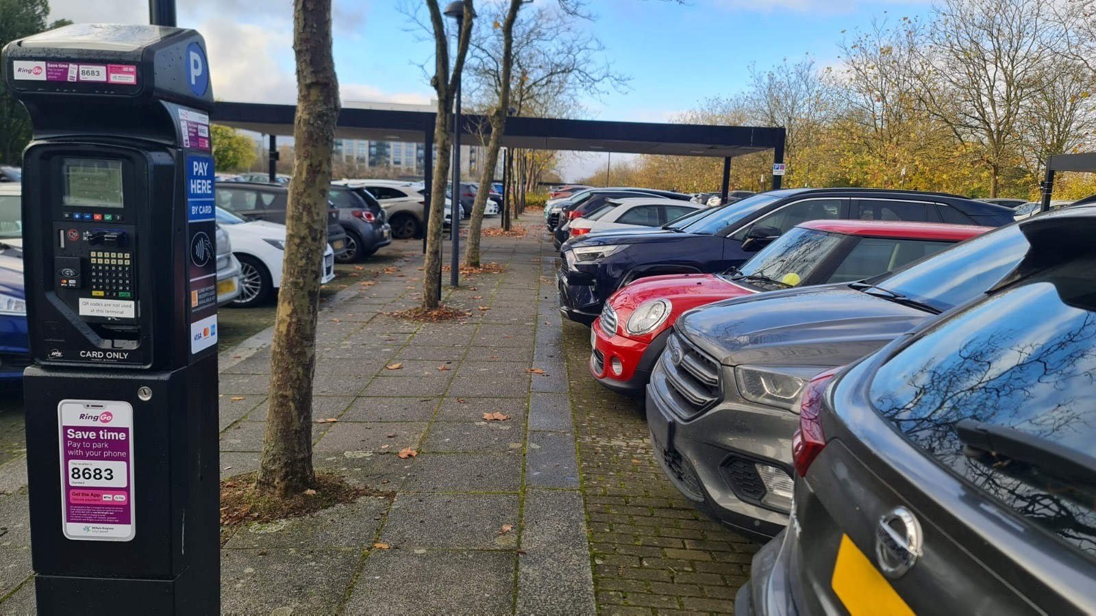

Entitlement

Any resident who resides in a property located in Central Milton Keynes, built before 2023, who is over the age of 17 years, and who is the user of a vehicle that is registered to the applicant’s address, may apply for:

* one resident permit per person
* one visitor permit per person
* unlimited visitor day vouchers

A full list of eligible properties is shown in the **List of Eligible Addresses**.

If your property is not shown in the **List of Eligible Addresses**, then it is likely that the property was built after 2023 when the Local Planning Policy was changed to car free developments. As an alternative, residents of the car free developments are eligible to apply for the **Central Milton Keynes – employee** permit. [add link to guidance notes]

Permits are not required for motorcycles or if your property has a private driveway/off road parking.

Visitor permits are available and can be purchased by a resident of the property.

Proof of residence and vehicle ownership must be provided before your application can be approved. The Council reserves the right to request further proof of residence or vehicle ownership if necessary.

Apply here: <https://permits.paysmarti.co.uk/acct/miltonkeynes>.

For any permit queries please email [miltonkeynespermits@imperial.co.uk](mailto:miltonkeynespermits@imperial.co.uk).

Proof of Residency

One of the following documents in your name will be accepted:

* Council Tax Bill ‐ must be the current year’s bill.
* Tenancy Agreement ‐ must be current & signed by all the relevant parties.
* Utility Bill ‐ Water/Electric/Telephone or Gas bill ‐ must be less than three months old.
* Driving Licence.
* Bank Statement (within last three months).

Proof of residence must be provided before your application can be approved. The Council reserves the right to request further proof of residence if necessary.

Proof of Vehicle Ownership

One of the following documents in your name will be accepted:

* V5 Log Book

Proof of ownership may be provided before your application can be approved. The Council reserves the right to request further proof of vehicle ownership if necessary.

Conditions

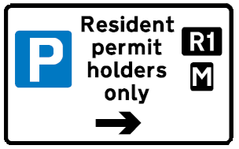All permits issued by Milton Keynes City Council are virtual. The permit allows you to park your vehicle within any parking space identified by the **R1** symbol on the signs adjacent to the bays, free of time limits and parking charges.

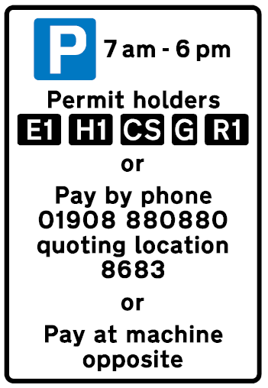When parking in Central Milton Keynes, other than the parking areas where the **R1** symbol is shown, you may need to pay the parking charge. The time limits and charges may vary so please follow the signs for guidance.

When parking, please ensure that you check the time limits for the chosen bay, which are always displayed on the signs adjacent to the bays.

The permit does not allow you to park on yellow lines, footways and verges, taxi ranks, disabled bays or loading bays. If you do, you risk being issued with a Penalty Charge Notice.

The resident’s permit is not transferable between vehicles, but a permanent change of vehicle can be made. If you need to change your vehicle during the validity of your parking permit, you must log into your account and change the vehicle details to update your permit.

If you no longer require your permit and there is more than six months remaining on it, you can obtain 50% of the cost of the annual parking permit. To do this you will need to apply for a refund through your online permit account.

Refunds will either be paid to the debit/credit card used to pay for the permit or by BACS. There are cheque or cash refunds.

Any refund will start from the date that the application refund was received and may take up to 4-weeks to be processed.

The Council reserves the right to revoke any permit if the Council has reason to believe that it is not being used in accordance with the regulations.

It is your responsibility to renew your permit. Applications for renewals should be made at least 5 days prior to the expiry of your permit to allow the application to be processed.

Where can you park?

|  |  |
| --- | --- |
| **Resident permit only parking places** (where the **R1** symbol is displayed on signs) | |
| North Ninth Street | Between North Row and Silbury Boulevard |
| North Tenth Street | Between North Row and Silbury Boulevard |
| North Fourteenth Street | Between North Row and Silbury Boulevard |
| Silbury Boulevard | Between North Ninth Street and North Tenth Street |
| North Row | Between North Twelfth Street and North Thirteenth Street |
| North Row | Between North Thirteenth Street and North Fourteenth Street |
| North Row | Between North Twelfth Street and North Thirteenth Street |
| North Row | Between North Eleventh Street and North Twelfth Street |
| North Row | Between North Seventh Street and Saxon Gate |
| South Fifth Street | Between Avebury Boulevard and South Row |
| South Eighth Street | Between Avebury Boulevard and South Row |
| South Ninth Street | Between Avebury Boulevard and South Row |
| South Tenth Street | Between Avebury Boulevard and South Row |
| South Row | Between South Sixth Street and South Seventh Street |
| South Row | Between South Eighth Street and South Ninth Street |

|  |  |
| --- | --- |
| **Standard tariff parking places** (where the **R1** symbol is displayed on signs) | |
| North Row | Between Grafton Gate and Witan Gate |
| North Row | Between Witan Gate and Saxon Gate |
| North Row | Between Saxon Gate and Secklow Gate |
| South Row | Between Secklow Gate and North Fourteenth Street |
| South Row | Between Witan Gate and Saxon Gate |
| South Row | Between Saxon Gate and Secklow Gate |

When parking, please ensure that you check the time limits for the chosen bay, which are always displayed on the signs adjacent to the bays.

Permit Period

All resident and visitor Permits are valid for 12 months. All permits will commence once payment has been made.

The Council does offer a visitors day voucher which is valid for 24 hours.

Permit Charges

The following charges will apply:

|  |  |  |
| --- | --- | --- |
| **Permit Type** | **Period** | **Charge** |
| Resident Permit | 12 months | **£25.00** |
| Visitor Permit | 12 months | **£25.00** |
| Visitor Voucher | 24 hours | **£1.00** |

Data Protection

Under the General Data Protection Regulation Act Milton Keynes Council has a legal duty to protect any information we collect from you.

Full details about how we use this data and the rights you have around this can be found at [www.milton-keynes.gov.uk/privacy](http://www.milton-keynes.gov.uk/privacy). If you have any data protection queries, please contact the Data Protection Officer at [data.protection@milton-keynes.gov.uk](mailto:data.protection@milton-keynes.gov.uk).

You can view the Privacy Notice for Milton Keynes Council at [Milton Keynes City Council corporate privacy notice | Milton Keynes City Council](https://www.milton-keynes.gov.uk/milton-keynes-council/privacy-notices/milton-keynes-city-council-corporate-privacy-notice).

List of Eligible Addresses

|  |  |
| --- | --- |
| **NAME OF ROAD** | **QUALIFYING PROPERTIES** |
| 1 North Sixth Street | All properties |
| 4 Merrivale Mews | Numbers 11 to 17, 21 to 27, 31 to 37 and 41 to 47 |
| 5 Merrivale Mews | Numbers 11 to 17, 21 to 27, 31 to 37 and 41 to 47 |
| 6 Merrivale Mews | Numbers 11 to 18, 21 to 28, 31 to 38, 41 to 48 and 51 to 54 |
| 7 Merrivale Mews | Numbers 11 to 15, 21 to 25, 31 to 35 and 41 to 45 |
| 8 Merrivale Mews | Numbers 11 to 15, 21 to 25, 31 to 35, 41 to 45 and 51 to -55 |

|  |  |
| --- | --- |
| **NAME OF ROAD** | **QUALIFYING PROPERTIES** |
| 9 Merrivale Mews | Numbers 11 to 15, 21 to 25, 31 to 35, 41 to 45, 51 to 55 and 61-65 |
| 10 Merrivale Mews | Numbers 11 to 16, 21 to 26, 31 to 36, 41 to 46, 51 to 56, 61 to 66 and 71 to 76, 81 to 86, 91 and 92 |
| 11 Merrivale Mews | Numbers 11 to 16, 21 to 26, 31 to 36, 41 to 46, 51 to 56, 61 to 66, 71, 72 and 73 |
| 100 North Second Street | Flat numbers 1 to 23 |
| 101 North Thirteenth Street | Flat numbers 1 to 12 |
| 152 North Row | Numbers 1 to 16 |
| 152 Silbury Boulevard | Flat numbers 1 to 43 |
| 199 Silbury Boulevard | Flat numbers 1 to 30 |
| 202 Silbury Boulevard | Flat numbers 1 to 47 |
| 252 Upper Fourth Street | Flat numbers 1 to 5 |
| 258 Upper Fourth Street | Flat numbers 1 to 10 |
| 260 Upper Fourth Street | Flat numbers 1 to 3 |
| 300 Saxon Gate West | City Church Flat |
| 302-340 Silbury Boulevard | Flat numbers 1 to 86 |
| 302 North Row | Rooms 40 and 42 |
| 304 South Row | Numbers 11, 12, 21, 22, 31, 32, 33, 34, 41, 42, 43, 44, 51, 52, 53, 54, 61, 62, 63, 64, 71, 72, 73 and 74 |
| 31 Rillaton Walk | Numbers 1 to 64 |
| 51 Rillaton Walk | Numbers 1 to 80 |
| 315 South Row | Numbers 11 to 13, 21 to 23, 31 to 35, 41 to 45, 51 to 58, 61 to 68, 71 to 78 and 81 to 88 |
| 325 South Row | Numbers 11 to 14, 21 to 24, 31 to 34, 41 to 44, 51 to 58, 61 to 68 and 71 to 78 |
| 352 Avebury Boulevard | Flat numbers 1 to 46 |
| 353 Avebury Boulevard | Flat numbers 101 to 124, 201 to 224, 301 to 324, 401 to 402, 501 to 524, 601 to 624, 701 to 724, 801, 902, 803, 814, 913, 1401, 1702, G01 to G13 |
| 399 South Row | Flat numbers 1 to 19 |
| 401 Witan Gate | Numbers 1 to 72 |
| 426 Avebury Boulevard | Flat numbers 1 to 21 |
| 475 Lower Twelfth Street | Flat numbers 201 to 210, 301 to 310, 401 to 410, 501 to 510 and 601 to 610 |
| 50 Mortimer Square | Numbers 1 to 76 |
| 503 Witan Gate | Numbers 1 to 96 |

|  |  |
| --- | --- |
| **NAME OF ROAD** | **QUALIFYING PROPERTIES** |
| 57 North Twelfth Street | Flat numbers 1 to 5 |
| 599 Witan Gate | Numbers 1 to 96 |
| 602 South Fifth Street | Numbers 11 to 18, 21 to 28, 31 to 38, 41 to 48 and 51 to 54 |
| 702 South Seventh Street | Flat numbers 1 to 16 |
| 801 Silbury Boulevard | Flat numbers 101 to 128, 201 to 208, 301 to 328, 401 to 422, 501 to 518 and 601 to 615 |
| 897 Silbury Boulevard | Numbers 1 to 24 |
| Avebury Boulevard | Numbers 552, 554, 556, 558, 560, 562, 564, 566, 568, 570, 572, 574, 576, 578, 580, 582, 602, 602A, 604, 606, 608, 610, 612, 614, 616, 618 and 620 |
| Secklow Gate | The Old Barn |
| North Eleventh Street | Numbers 1 to 71 (odd numbers only) |
| North Fourteenth Street | Numbers 2 to 30 (even numbers only) |
| North Ninth Street | Numbers 1 to 199 (odd numbers only) |
| North Row | Numbers 752 to 910 (even numbers only) |
| North Third Street | Numbers 1 to 24 |
| North Tenth Street | Numbers 2 to 198 (even numbers only) |
| North Thirteenth Street | Numbers 1 to 32 |
| North Twelfth Street | Numbers 1 to 56, 58, 60, 62, 64, 66, 68, 70 and 72 |
| Silbury Boulevard | Numbers 605A to 605C, 607A to 607J, 609A to 609J, 625A to 625D, 627A to 627J, 629A to 629J, 645A to 645C, 647A to 647J and 649A to 649J |
| South Eighth Street | Numbers 601 to 651 (odd numbers only) including 629A and 629B |
| South Ninth Street | Numbers 601 to 621, 623, 625, 627, 629, 631, 633, 635, 637, 639, 641, 643, 645, 647, 649, 651, 653, 655 and 657 |
| South Row | Numbers 351 to 449 and 551 to 581 (odd numbers only) |
| South Tenth Street | Numbers 602-658 (even numbers only) |
| Elder Gate | Numbers 548 and 550 |
| North Row | Numbers 206A to 206P, 208A to 208L, 210A to 210L and 212A to 212P |
| Petersfield Green | Numbers 1 to 36 |
| South Fifth Street | Numbers 775 to 799 (odd numbers only) |
| South Seventh Street | Numbers 776 to 800 (even numbers only) |
| Upper Third Street | Numbers 273 to 285 (odd numbers only) |
| Upper Fourth Street | Numbers 254 and 256 |