Consultation

**A proposal to create primary education provision at Whitehouse South, Milton Keynes**

**What is this consultation proposing?**

This six week consultation from 17 March 2025 to 27 April 2025 is seeking views about the proposal to create a new primary school at Whitehouse South. The purpose of this document is to provide background information about the proposal and feedback will be used to help finalise the specification for the new school.

**What role does the council have in place planning?**

The council has a legal duty to ensure there are sufficient school places for all children who are living in Milton Keynes. This duty extends to ensure there are enough suitable educational placements and resources available to meet the needs of children and young people with SEND in the area. This duty has to be met in the context of significant growth in new housing in the Milton Keynes area. By 2026, almost 300,000 people will live in Milton Keynes rising to 325,000 by 2037 (currently 287,000). Of particular importance to new families is the ability to obtain a local place at a quality school for their children. Although the pace of growth in Milton Keynes makes this a challenge, the council has continued to achieve this due to excellent partnership work with local stakeholders. Since 2017, five new mainstream schools have opened and ten expansion projects have been completed to accommodate the increase in the pupil population of just over 5,200 children.

The council outlines its plan to ensure sufficient school places each year in its ‘Mainstream Place Planning Forward View’ and sets out its vision for SEND provision in its ‘Specialist Provision Place Planning Forward View’. Place planning groups with colleagues from the primary, secondary and SEND sectors, have been established to ensure a collaborative approach to place planning and admissions. These groups work together to ensure that the council meets its statutory sufficiency duties and that any place planning matters are holistically considered with the sector, including the timing and release of education places when it has been identified that additional places are required.

**What is driving the need to consider new education provision at Whitehouse South?**

The area of Whitehouse South is located in the Western Expansion Area (WEA) of Milton Keynes (see Annex A). The WEA is currently the largest of the major development sites in Milton Keynes with 6,600 homes to be built (a pupil yield of c.380 pupils per year group). When complete (in around 2032) it will be comparable in size to Buckingham. The WEA will have four primary schools, three of which are already open, and one secondary school that opened in 2020. Pupil projections indicate that the fourth primary school at Whitehouse South is needed in 2028 and will eventually provide 90 places per year group from Year R to Year 6 with a total of 630 places.

Without new provision opening, children moving into the area as the development grows will be unable to access a local school place. The number of EHCPs (Education, Health, and Care Plans) in Milton Keynes has been increasing steadily since 2018/19 with demand for specialist provision expected to continue rising each year. Including a specialist unit as part of the new primary school will support to meet this demand and to, wherever possible, keep children in their local communities and within Milton Keynes.

**What is the proposal?**

The proposal is to deliver a new primary school offering 90 places from Year R to Year 6, a specialist unit for a small number of children with special educational needs (SEND) and nursery provision. In order to address the needs of the local population, whilst minimising the impact on other schools across Milton Keynes, it is likely that the new school would open initially with a reduced admission number with more places released gradually in line with growth. This consultation is seeking views from stakeholders about this proposal and how the specification for the new school should look. The table below provides general information about the proposed school provision required:

|  |  |
| --- | --- |
| Proposed opening date | 1 September 2028 |
| Phase | Primary school for mixed gender with an age range from 2 years to 11 years |
| Number of places | Primary capacity of 630 with 90 places in Year R to Year 6  SEND unit capacity of up to 24 pupils  39 place FTE nursery for 2 to 4 year olds |
| Mainstream catchment area | It is anticipated that the school will serve residents living in the Whitehouse area of the Western Expansion Area |

**Next steps**

This consultation provides all stakeholders with an opportunity to comment on the proposal for a new primary school at Whitehouse South in the WEA. At the end of the consultation, officers will consider all comments made and feedback gathered will be used to finalise the council’s specification for the new school if required. Should the process continue the specification for the new school will be published and a free school presumption competition will be launched in the summer term of 2025. This will be open to multi academy trusts that are able to deliver high quality education and establish the school ready for opening in September 2028.

**How can I contribute to this consultation?**

This consultation seeks views from all stakeholders including schools, parents and carers, local residents and any other interested parties. We are keen to hear as many views as possible about this proposal. Please respond by completing the online form or by email, stating your name, organisation, whether you are a parent or local resident and your comments to:

[sufficiencyandaccess@milton-keynes.gov.uk](mailto:sufficiencyandaccess@milton-keynes.gov.uk)

or in writing to:

Education Sufficiency, Milton Keynes City Council, Civic, 1 Saxon Gate East, Milton Keynes, MK9 3EJ



**This consultation will end on 27 April 2025**

**Annex A - WEA School location map**

**Fairfields Primary opened 2017**

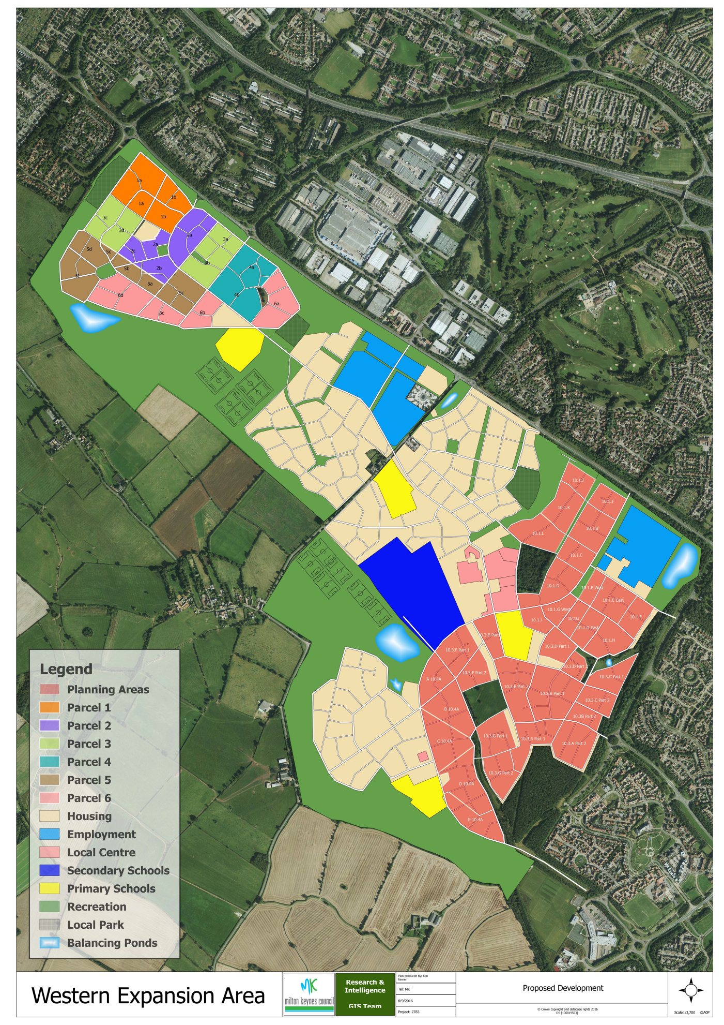

**Watling Academy (secondary) opened 2020**

**Whitehouse Primary opened 2016**

**Watling Primary opened 2023**

**Fourth proposed primary school – opening planned for September 2028**