Informal ConsultationReport

High Street, Haversham Proposed 20mph Zone

On 16September 2024 the Council uploaded a proposal onto the Councils website for a proposed 20mph Zone in High Street, Haversham.

Start: 16September 2024

End: 11 November 2024

Period: 56 days



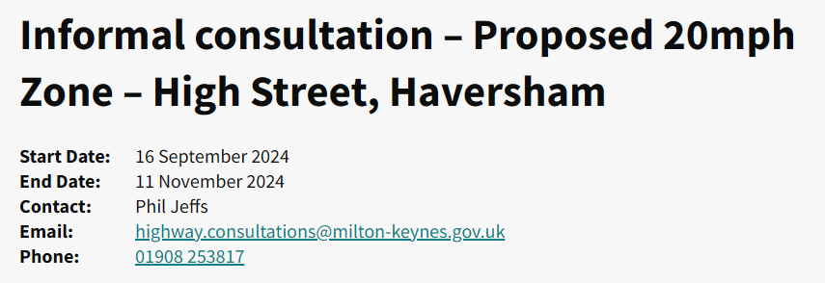

Representations (responses received)

The Council received 52 representations during informal consultation (as shown in Annex A to this report.

11 objections to the proposals

33 in support of the proposals

08 commented on the proposals.

**Objections (In summary)**

Below is a summary of the reasons why 11 representatives objected to the proposed 20mph zones:

|  |  |
| --- | --- |
| *1* | The representative opposes the proposed 20mph zone due to concerns about increased noise, especially during summer with open windows, as their property is very close to the road. They also highlight a potential safety issue, as a planned speed hump near their driveway entrance would make entering and exiting the driveway more challenging and potentially hazardous. |
| *2* | A resident of Haversham's High Street objects to the proposed 20mph zone and road humps, arguing that it is unnecessary. They highlight that, unlike Wolverton Road near the local primary school, the High Street lacks public buildings warranting such measures, aside from the Greyhound pub (with its own car park) and a church on a dead-end road. |
| *3* | The resident, a cyclist, raises concerns that the proposed 20mph speed limit and road humps may inadvertently worsen cyclist safety and hinder the cycling experience in Haversham. |
| *4* | The resident opposes the 20mph speed limit and speed bumps, viewing them as an unnecessary expense. They argue that existing parked cars naturally limit speeding, and while some drivers may still exceed limits, a lower speed limit is unlikely to deter such behaviour. |
| *5* | They strongly oppose the installation of speed bumps, arguing that these would be inappropriate for the historic character of the village, which has several listed properties. They also express concerns that speed bumps could exacerbate surface water flooding issues and suggest that funds would be better allocated to more pressing needs, such as flood prevention. |
| *6* | The resident, opposes the addition of speed bumps on High Street, citing concerns about excessive noise from vehicles going over the bumps and potential vehicle damage. |
| *7* | The resident argues that the proposed 20mph zone with speed bumps does not align with local safety needs or legislative standards. Key concerns include:   1. **Inappropriate Placement of Speed Bumps** 2. **Impact on Traffic Flow and Accessibility** 3. **Environmental and Noise Impact** 4. **Suggestions for Alternative Measures** The resident suggests less intrusive options, such as electronic speed indicators, enhanced pedestrian crossings, or road narrowing, which might address safety without the drawbacks of speed bumps. |
| *8* | The resident expresses frustration with the consultation process, feeling it is biased toward implementing the 20mph limit.  The resident is particularly concerned that the process disadvantages elderly residents, some of whom may not have internet access or confidence to submit objections to the Council. |
| *9* | The resident strongly opposes the placement of speed humps near their driveway, citing concerns about worsening water runoff and debris accumulation due to increased rainfall. Located at a low point on the road, directly opposite the pub, they anticipate that speed humps would exacerbate these issues. |
| *10* | The resident argues that the proposed 20mph zone with speed bumps does not align with local safety needs or legislative standards. Key concerns include:   1. **Inappropriate Placement of Speed Bumps** 2. **Impact on Traffic Flow and Accessibility** 3. **Environmental and Noise Impact** 4. **Suggestions for Alternative Measures** |
| *11* | The resident opposes the 20mph speed limit and did not sign the petition in support. While acknowledging occasional speeding on High Street, they believe it does not warrant drastic measures like speed humps. They express skepticism about the effectiveness of a 20mph limit if enforcement of the existing 30mph limit has proven challenging.  They are particularly opposed to speed humps due to environmental concerns, noting that the noise, air pollution from acceleration and deceleration, and vibrations would negatively affect residents with houses close to the road. |

**Officer response and recommendations**

Due to the high number of objections for the proposed 20mph zone, MKCC will no longer be implementing this proposal. After internal discussions it was felt that the proposed road humps would have a negative effect to residents of The High St, Haversham. With noise and the proximity of the properties to the proposed traffic calming features being the deciding factors.

Without road humps a 20mph proposal can no longer be proposed, this is due to the existing 85th%ile (*) speeds being currently too high (34mph southbound and 35.9mph northbound). They don’t fall within the speed thresholds MKCC has put in place for new 20mph zones and speed limits after discussions with Thames Valley Police.

As an alternative, MKCC will be looking at alternative options to reduce speeding through the village, which will include the following:

* Reducing the trigger speeds of the existing speed indicator devices to encourage motorists to reduce their speeds.
* New gateway features at the entrance points to The High Street (including rumble strips).
* Signing and lining improvements.

***(*)85th Percentile Speed (mph)****– The 85th percentile speed is the speed at or below which 85 percent of the drivers travel on a road segment.  Motorists traveling above the 85th percentile speed are considered to be exceeding the safe and reasonable speed for road and traffic conditions.*

List of annexes

Annex A – Haversham 20mph Speed Limit - Proposal

ANNEX A

Proposed 20mph Zone – High Street, Haversham

