Informal ConsultationReport

H9 Groveway, Simpson Drive Road Safety Improvements

On 09October 2024 the Council uploaded a proposal onto the Councils website for a proposed right turn ban into Simpson Drive from the H9 Groveway.



Start: 09September 2024

End: 18 October 2024

Period: 40 days

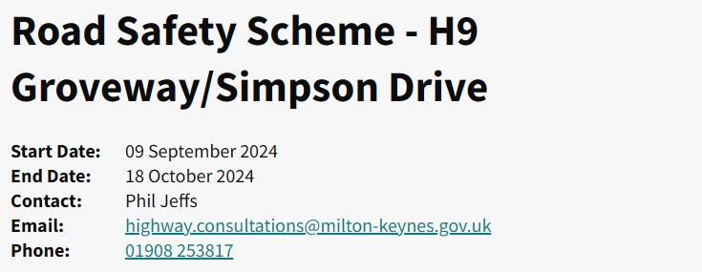

Representations (Response received)

The Council received 17 representations during statutory consultation (as shown in Annex A to this report.

06 objections to the proposals

03 in support of the proposals

08 commented on the proposals.

**Objections (In summary)**

Below is a summary of the reasons why 16 representatives objected to the proposed 20mph zones:

|  |  |
| --- | --- |
| *1* | *I thought it was a complete block on right turns that was proposed. They are the ones that cause the incidents.* |
| *2* | *As a regular user of this junction (I live in Simpson), I agree that it needs to be simplified to reduce the many risks that it contains because of the difficult sight-lines, and potential for confusion about priorities. I know of two people who have been involved in collisions there, and have seen endless near-misses, as well as Mexican-standoffs where people misunderstand how to use it.*  *However, I do not believe that the proposal on the table deals with it adequately, because it leaves the right turn from Simpson onto Groveway which has perhaps greatest potential for a high speed collision. Vehicles sweep down Groveway at high speed, towards the bridge over the river, and the sight-line when turning right out of Simpson is very poor. I personally drive the long way round to avoid this right turn.* |
| *3* | *Having seen the proposals I feel this would be a lost opportunity to improve road safety, and that the central reservation should just be closed. For anyone who wants to "turn right" coming out of Simpson Drive, it really isn't a lot further to turn left, go up to the roundabout and come back round. I myself often turn left out of Newport Road onto H7 and go up to the roundabout to turn round and come back down the H7, rather than sitting queueing for several minutes to turn right, which is often risky.* |
| *4* | *As a user of the Groveway / Simpson Drive junction I understand the concerns about this junction. However I believe continuing to allow turning right out of Simpson Drive onto Groveway eastwards will in fact still mean there is a high risk of collisions and potentially with worse impact given vehicles turning out of Simpson Drive onto a single carriageway on the H9 Groveway where vehicles already on the latter have a tendency to be accelerating to high speeds as they drive on past the turning of Tinkers Bridge and Newport Road. I therefore believe it would be safer to remove the ability of turning right out of Simpson Drive as well.* |
| *5* | *There have been several fatalities and innumerable accidents and near misses at this crossover since I moved to the village over 26 years ago. There have been a few changes over the years in the road layout and the most recent seems to confuse a great deal of people who appear to misunderstand the rule I of the road, ie - give way to the right.*  *In my opinion the crossover should be closed completely. This has already been done in other areas in MK. There are roundabouts in the near vicinity both ways which would only add a few minutes to anyone’s journey, and make entering and leaving the village undoubtedly a great deal safer.* |
| *6* | *As a long- time resident of Simpson, I should like to express disappointment in the current proposal for changes to the H9 Groveway junction.*  *A lot of time and money has already been invested in tweaking this junction (at least twice in my time). And I don't think current plans go far enough to ensure better road safety in future.*  *Rather than making this a partial improvement by closing the junction to right turns into Simpson, why not cease right turns from both in and out of Simpson? There are roundabouts in close proximity to the east and west so turning around is not a huge inconvenience. Allowing only left turns into and out of Simpson Drive would make it a much safer junction.*  *I use this junction daily and rarely turn right out of Simpson, preferring to turn left into the flow of traffic then swing around at the Ashland/V8 roundabout.* |

**Officer response (to the objections)**

*A complete closure of the gap (removing right turns in and out of Simpson Drive) would not be possible due to the potential knock-on impact to other junctions along the H9 – the Newport Road junction highlighted in red below being one of them. There is the potential for dangerous U-turn manoeuvres at these junctions, as motorists might not wish to travel to the next roundabout.*

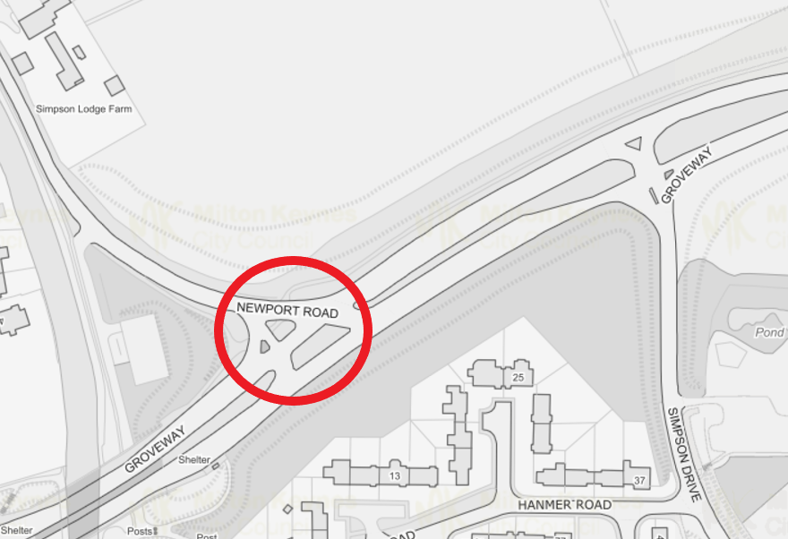

*The right turn out of Simpson Drive will be safer, as there will be no conflicting right turn movements into Simpson Drive. The proposal will also address the poor visibility issue for vehicles exiting onto the H9 from Simpson Drive, as motorists making this manoeuvre will now be able to see vehicles approaching without being blocked by vehicles wishing to enter Simpson Drive.*

**Officer Recommendations**

*The Council will be progressing with the scheme; however, the following amendments will be made to the original proposal:*

* *New 40mph speed limit – exact length to be confirmed.*
* *Additional Vehicle Activated signs advising motorists of traffic turning right out of Simpson Drive*
* *New Speed indicator devices reminding motorists to reduce speeds on approach to the hazard.*

List of annexes

Annex A – Representations

Annex B – H9 Groveway/Simpson Drive Junction Proposals

ANNEX A

Representations

|  |  |  |  |
| --- | --- | --- | --- |
|  | **Representative** | **Received** | **Comments/Objection** |
| **1** | Member of the Public | 06-09-2024 | **Objection**  I thought it was a complete block on right turns that was proposed. They are the ones that cause the incidents. |
| **2** | Member of the Public | 06-09-2024 | **Objection**  As a regular user of this junction (I live in Simpson), I agree that it needs to be simplified to reduce the many risks that it contains because of the difficult sight-lines, and potential for confusion about priorities. I know of two people who have been involved in collisions there, and have seen endless near-misses, as well as Mexican-standoffs where people misunderstand how to use it.  However, I do not believe that the proposal on the table deals with it adequately, because it leaves the right turn from Simpson onto Groveway which has perhaps greatest potential for a high speed collision. Vehicles sweep down Groveway at high speed, towards the bridge over the river, and the sight-line when turning right out of Simpson is very poor. I personally drive the long way round to avoid this right turn.  Given the presence of closely-spaced roundabouts on Groveway, I believe that there is potential to close all of the right turns, including the one into Newport Road, to reduce conflicting movements and poor sight-lines, leaving only left turns into and out of Simpson and Newport Road. Doing this might also reduce the amount of “rat running” through Simpson at peak times. I think it would also be wise to restrict speed coming down the hill from the west to the bottleneck over the bridge, perhaps coupling that with throttling the approach to the bridge further back, because as things stand at the moment the layout encourages “racing” down that hill, with cars attempting to overtake before the bottleneck. |
| **3** | Member of the Public | 06-09-2024 | **Comments**  Only comment would be with regards to visibility splay for vehicles sitting in central reservation waiting to turn right and join traffic.  You have the splay as verge up to junction, this is relying on the vegetation being kept to short length, discussions with environment around removing vegetative strips on grid roads particularly at junctions with visibility splays to reduce maintenance and not compromise safety including hardening these verge strips.  This discussion is being escalated next month across network to set principles and look to possibly retro fit some sections changing from verge to hard surfacing.  In light of the above may need to consider changing verge for a hard surface? |
| **4** | Member of the Public | 16-09-2024 | **Objection**  Having seen the proposals I feel this would be a lost opportunity to improve road safety, and that the central reservation should just be closed. For anyone who wants to "turn right" coming out of Simpson Drive, it really isn't a lot further to turn left, go up to the roundabout and come back round. I myself often turn left out of Newport Road onto H7 and go up to the roundabout to turn round and come back down the H7, rather than sitting queueing for several minutes to turn right, which is often risky. |
| **5** | Member of the Public | 17-09-2024 | **Objection**  As a user of the Groveway / Simpson Drive junction I understand the concerns about this junction. However I believe continuing to allow turning right out of Simpson Drive onto Groveway eastwards will in fact still mean there is a high risk of collisions and potentially with worse impact given vehicles turning out of Simpson Drive onto a single carriageway on the H9 Groveway where vehicles already on the latter have a tendency to be accelerating to high speeds as they drive on past the turning of Tinkers Bridge and Newport Road. I therefore believe it would be safer to remove the ability of turning right out of Simpson Drive as well.  I would be grateful if you would confirm receipt of this feedback. |
| **6** | Member of the Public | 18-09-2024 | **Comments**  I wish to comment on the above proposal.  Generally, I think the thrust of the proposal is probably sensible given the quoted occurrence of accidents and near misses.  For context could you please provide me, under the Freedom of Information Act, the statistics of accidents/near misses that underpin your proposal which are absent from your extremely brief consultation document.  However, I have grave reservations about the proposal to make extensive use of grass verge in the scheme. Based on my experience of the current state of grass verges on MK grid roads, it is my view that the proposal will not solve the problem as vehicles exiting Simpson drive will have a severely impaired view of traffic approaching from the west (V8) unless the grass is properly and frequently maintained. There are stretches on MK grid roads at roundabouts at present where unmown weeds are often up to 900mm tall (particularly at roundabouts) and present a danger to road users.  I trust these comments will be taken into consideration. |
| **7** | Member of the Public | 20-09-2024 | **Comments**  The proposed layout changes for this junction appear to be reasonable, especially closing off the Simpson junction to east-bound traffic on the Groveway although, this will cause much local inconvenience and add significantly to the ‘upto the OU roundabout and back’ traffic that will result.    However, the proposal is unlikely to make a significant difference to this accident black-spot. Neither this nor previous changes have addressed the fundamental issue – excessive traffic speed on the Groveway. There are four crossing on the stretch of dual carriageway between the Simpson roundabout and the new one for the OU. All these local side-roads access a fast main road giving limited reaction times and considerable risk. The pull out from the Newport Road is particularly bad in this respect. In the last week I have been ‘hassled’ by cars close behind wishing to race away from the OU roundabout towards the west and this was at least 100 m before the Simpson turn. Additionally, the Groveway as it crosses east over the Grand Union Canal, drops sharply downhill and provides a ready opportunity for traffic to speed up so that vehicles are passing the slip road and right turn into Simpson Drive at approaching 70 mph. The solution to this situation can only be a speed limit of at least 50 mph along the Groveway between the two roundabouts. Potentially this might obviate the need for the rather dramatic solution in the proposal. |
| **8** | Member of the Public | 26-09-2024 | **In support**  Just emailing to express our support for the proposed changes to the Groveway/Simpson Drive junction. As Simpson residents, we use this junction multiple times a day and have witnessed many ‘near misses’ and believe these changes would improve the safety of this junction. |
| **9** | Member of the Public | 27-09-2024 | **Comments**  SUGGESTIONS:  - Right turn ban from Simpson Drive onto H9 and as proposed right turn ban into Simpson  - 40 mile speed limit from and to OU roundabout. |
| **10** | Member of the Public | 27-09-2024 | **Objection**  There have been several fatalities and innumerable accidents and near misses at this crossover since I moved to the village over 26 years ago. There have been a few changes over the years in the road layout and the most recent seems to confuse a great deal of people who appear to misunderstand the rule I of the road, ie - give way to the right.  In my opinion the crossover should be closed completely. This has already been done in other areas in MK. There are roundabouts in the near vicinity both ways which would only add a few minutes to anyone’s journey, and make entering and leaving the village undoubtedly a great deal safer.  I would imagine this option would save tax payers money as it would likely be the cheapest option, not to mention save lives. |
| **11** | Member of the Public | 30-09-2024 | **In support**  I have lived in Simpson for over 20 years and have been increasingly concerned over the H9 / Simpson Drive Junction with the increase of traffic, traffic speed and in the general risk taking at junctions .  To remove the right turn option from Groveway into Simpson is a positive step and I would support it.  This option should not be looked at in isolation as there are other junctions from Simpson to the Simpson roundabout. I do feel that a 40 m.p.h. limit should be imposed as was included in traffic calming to other grid roads in the City for example on H4 Great Holm area .Many drivers drive too fast for the road conditions |
| **12** | Member of the Public | 01-10-2024 | **Objection**  As a long- time resident of Simpson, I should like to express disappointment in the current proposal for changes to the H9 Groveway junction.  A lot of time and money has already been invested in tweaking this junction ( at least twice in my time). And I don't think current plans go far enough to ensure better road safety in future.  Rather than making this a partial improvement by closing the junction to right turns into Simpson, why not cease right turns from both in and out of Simpson? There are roundabouts in close proximity to the east and west so turning around is not a huge inconvenience. Allowing only left turns into and out of Simpson Drive would make it a much safer junction.  I use this junction daily and rarely turn right out of Simpson, preferring to turn left into the flow of traffic then swing around at the Ashland/V8 roundabout.  Thank you for the opportunity to comment. |
| **13** | Member of the Public | 04-10-2024 | **Comments**  Thank you for the opportunity to comment on these proposals.  You probably won’t recognise my name, but I rang Highways a couple of months back following a near miss turning right out of Newport Road, Woughton Park into Groveway and offering to be contacted to give further particulars, though this was never taken up.  I’ve lived at Woughton Park since March 1984 and my experience is that traffic is now speeding through this section of the H9 from the Marlborough Street, because it is a long and straight stretch heading up to the OU.  The problem for manoeuvres like mine is that you have to commit to crossing a dual carriageway when the over-taking lane is too fast, whilst the slow lane is obscured by overgrown vegetation from the canal side.  In sum, junction alterations with Simpson Drive won’t tackle this hazard.  I’d be grateful if you could acknowledge safe receipt of my input this time please. |
| **14** | Member of the Public | 05-10-2024 | **In support**    I reside in the parish of Old Woughton and frequently use this road junction. Although implementing the proposals will cause me and others some inconvenience, I support them.  I also suggest measures to reduce the speed of eastbound traffic along Grovewa - reducing the carriageway to a single lane east of the roundabout with the V8 would help. |
| **15** | Member of the Public | 10-10-2024 | **Comments**    We live in Staple Hall Road and generally access the grid road via Simpson Drive onto Groveway (primarily due to the excessive traffic on Bilton Road at the other end of our street).  While we welcome the proposal in general, as this could reduce the stress of trying to turn right from Simpson Drive, we are very concerned by the proposed road layout provided in the PDF design.  The idea of straightening the right-hand edge of the right turn and in effect turning it into a 90 degree T junction, will in practice mean less opportunity to egress from the turning onto the very high speed section of Groveway, particularly as traffic wanting to turn right onto Simpson Drive, will now also be crossing this junction to turn around at the next roundabout.  We are further concerned that due to the council's policy of allowing verges to grow wild for rehabitating purposes (which in general we applaud) the proposed new verge to the left of the junction, will likely (after spring growth) radically reduce the sight line to the left of the junction.  We think together it is likely that this will make the junction more dangerous rather than supporting the intention of making it less dangerous. |
| **16** | Member of the Public | 17-10-2024 | **Comments**  Have looked at the proposal for the H9 Groveway/Simpson Drive junction to improve the road safety and would like to see the right turn ban into Simpson Drive from the H9, as soon as possible.  Would like to see it go further and stop all right turns across the central reservation as the H9 is a national speed limit road where a dual carriage way going down into a single lane. Visibility at the crossing points is poor, especially when turning right into Tinkers Bridge. Would it be possible to close the turning as has happen in other parts of the city? |
| **17** | Member of the Public | 21-10-2024 | **Comments**  I have previously, recently written to Paul Trendell about this junction. My view is that if the entrance to the Open University justifies a large roundabout when traffic leaves the OU in any numbers only once a day, and those drivers do have the option of leaving their premises via roundabouts in a nearby access/egress entrance, (Brickhill Street), declining to create a roundabout for the Groveway/Simpson Drive junction is questionable. After all, the argument is that the Groveway/Simpson Drive junction has been a contributory cause of accidents, injuries, and a death so must be dangerous. Those causes could not be attributed to the OU drive entering/leaving Groveway but you created a large roundabout for it! I recognise that that roundabout is also to be used at some time in the future when housing may be built on the south side of that junction, (hence the dead-end spur,) but that is surely speculative guesswork whereas Groveway/Simpson Drive has data suggesting the need for change.  A three-way roundabout, (not a small painted dot on the road surface) would allow traffic to continue to flow in all directions and not force traffic wanting to turn from Groveway travelling eastwards into Simpson Drive could do so and not add to the traffic flow at the large, new OU roundabout. I also question the suggestion that traffic should be allowed to emerge from Simpson onto Groveway turning eastwards is regarded as acceptable but traffic should not be allowed to turn from eastbound Groveway into Simpson Drive - Why Not?  What you are suggesting is not the best overall solution. A substantial roundabout will be a safe improvement without causing anyone to have to take unnecessary diversions. That alone should be a reason as it helps save the world from global warming! |

ANNEX B

H9 Groveway/Simpson Drive Junction Proposals

