Statutory Consultation **Report**

NOT-051

Report Summary

This report provides a summary of the statutory consultation exercise and for the objections received during the consultation period to be formally considered by the delegated decision maker; and to seek a decision whether to uphold any of the objections.

Proposal

Milton Keynes City Council (“the Council”) is proposing to construct traffic calming measures consisting of three speed humps under Section 90A of the Highways Act 1980:

**MILTON KEYNES CITY COUNCIL**

**(PROPOSED TRAFFIC CALMING SCHEME) (YARDLEY ROAD, OLNEY) 2024**

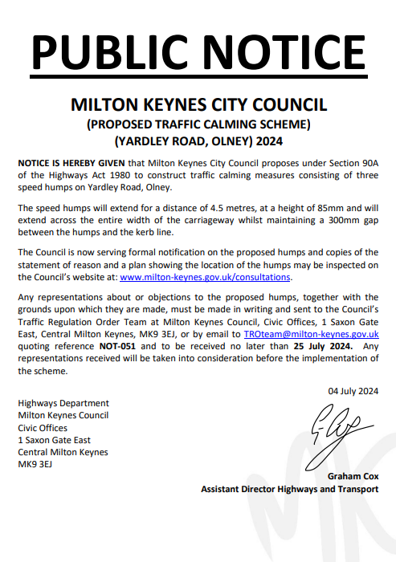 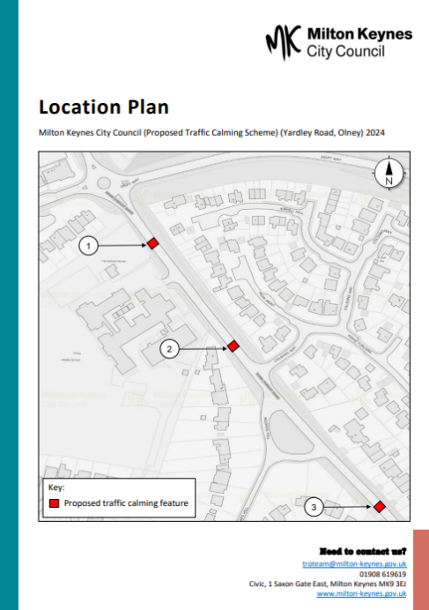 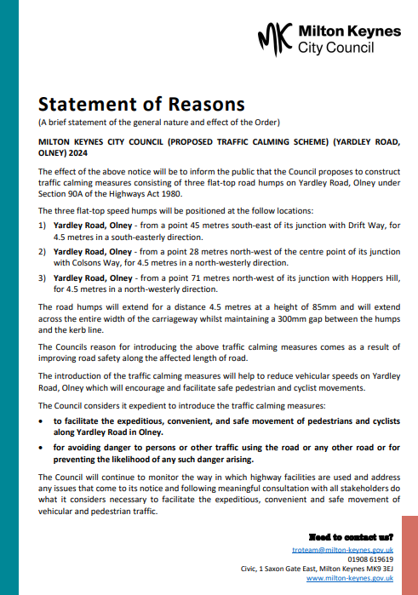

The general effect of the above Section 90A notice will be to construct traffic calming measures consisting of three speed humps on Yardley Road, Olney. The speed humps will support the proposed 20mph speed zone in Olney which includes Yardley Road, where the MEAN speeds are slightly above the 20mph threshold.

Statement of reasons

The Councils reason for introducing the above traffic calming measures comes as a result of improving road safety along the affected length of road.

The introduction of the traffic calming measures will help to reduce vehicular speeds on Yardley Road, Olney which will encourage and facilitate safe pedestrian and cyclist movements.

**Need to contact us?**

xxxxxxxxxxxx@milton-keynes.gov.uk

01908 XXX XXX  
Civic, 1 Saxon Gate East, Milton Keynes MK9 3EJ  
www.milton-keynes.gov.uk

The Council considers it expedient to introduce the traffic calming measures:

* **to facilitate the expeditious, convenient, and safe movement of pedestrians and cyclists along Yardley Road in Olney.**
* **for avoiding danger to persons or other traffic using the road or any other road or for preventing the likelihood of any such danger arising.**

Statutory Consultation

On 04 July 2024, the Council served the notice of proposal which initiated 21-days of statutory consultation.

**Statutory consultees:**

* Chief of Police (Thames Valley Police)
* British Motorcycle Federation
* South Central Ambulance Service
* Bucks Fire and Rescue Service
* Road Haulage Association
* Freight Transport Association
* Cycling UK
* British Motorcycle Federation
* Milton Keynes Parks Trust
* Affected Ward Councillors
* Affected Parish Council
* The Council’s Waste Management
* The Council’s Transport Service
* The Council’s Customer Service



Start: **04 July 2024**

End: **25 July 2024**

Period: **21 days**

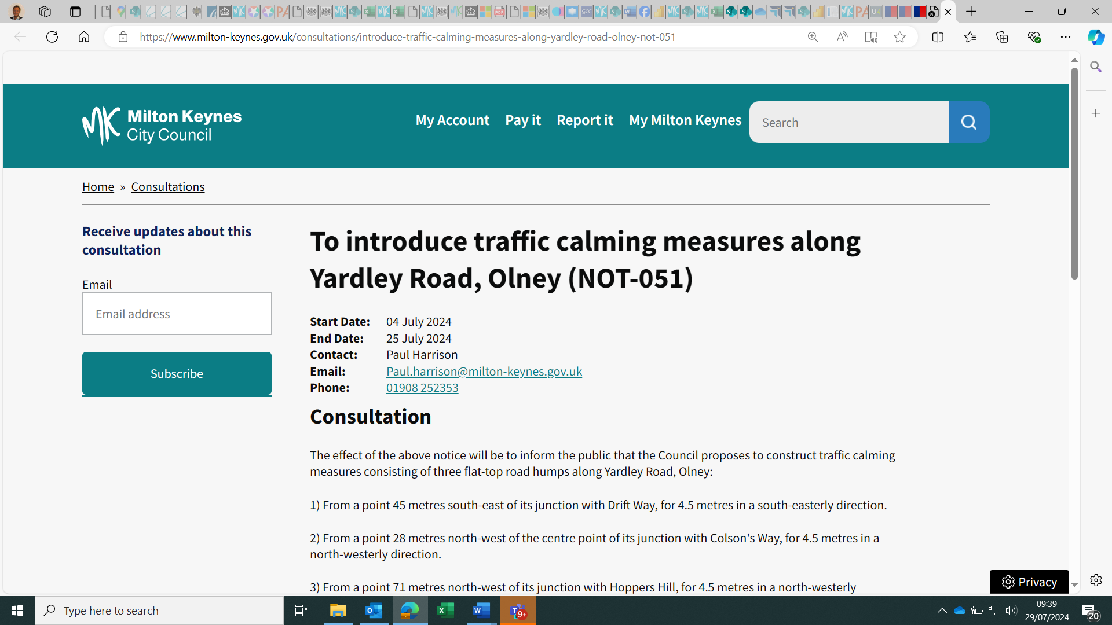

[To introduce traffic calming measures along Yardley Road, Olney (NOT-051) | Milton Keynes City Council (milton-keynes.gov.uk)](https://www.milton-keynes.gov.uk/consultations/introduce-traffic-calming-measures-along-yardley-road-olney-not-051)



The notice of proposal was served……….

in the local newspaper

on the Council website

on site

Response

The Council received 03 representations during statutory consultation (Annex A).

0

3

objection to the proposals

0

0

in support of the proposals

0

0

commented on the proposals

0

0

3

Objections (In summary)

|  |  |  |
| --- | --- | --- |
| **Representative** | **Date** | **Summary** |
| Member of the Public | 08-Jul-24 | The proposal offers no evidence of the risks posed by the existing 30mph limit. |
| Member of the Public | 16-Jul-24 | This is a waste of taxpayers money. The main issues that the Council should be tackling is parking and congestion. |
| Member of the Public | 23-Jul-24 | There has been no incidents during the last 5 years reported on crashmap.  Speed humps are a menace for those with osteoporosis and bad backs, and emergency vehicles.  They are bad for the environment (noise and pollution by cars speeding up/slowing down in-between), and vehicle wear & tear. |
|  |  |  |

Officer Recommendations

|  |
| --- |
|  |

*The proposed traffic calming features will support the proposed 20mph speed zones in Olney (Reference: TRO-411) as they will help to reduce vehicular speeds along the above lengths of road, which will encourage and facilitate safe pedestrian and cyclist movements.*

*The traffic calming features will be positioned along Yardley Road, outside Olney Middle School as a result of the high volume of pedestrian movement crossing the road.*

*Therefore, it is the Officers recommendation that the three objections received during statutory consultation, should not be upheld and that Officers be authorised to proceed with the construction of the traffic calming features on Yarley Road Olney.*

*Officers will continue to monitor vehicular speeds once the new traffic calming features have been constructed along Yardley Road, to gauge the effectiveness of the scheme.*

Formal Consideration

The Assistant Director Highways and Transport must now now formally consider the three objections received during statutory consultation and the Officers recommendations.

Decision

Accordingly, under my delegated powers, I have formally considered the three objection received during statutory consultation and the Officers response and recommendations and am satisfied that the reasons for constructing the traffic calming features, consisting of three speed humps on Yardley Road, Olney, are justified and that there are no valid reasons why the proposed features can not be constructed.



|  |  |
| --- | --- |
| Delegated Decision Maker:  Signed: …………………………………………………………………  **Assistant Director Highways and Transport** | Date: ………02/08/2024…………………… |
|  |  |

List of annexes

Annex A – Representations received during statutory consultation

List of background papers

Notice of Proposal

Location Plan

Statement of Reasons