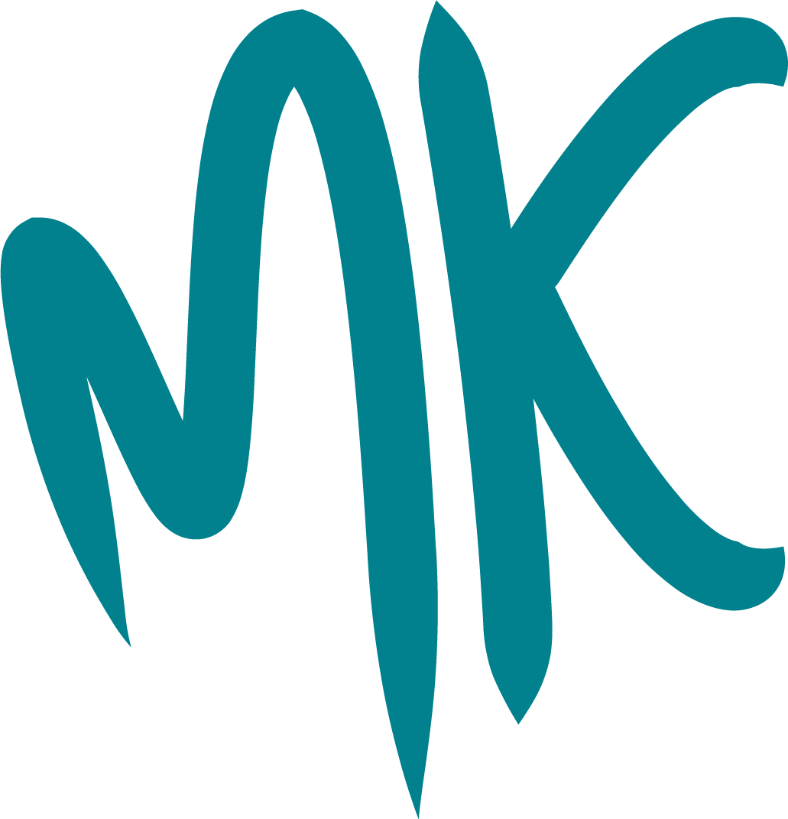
GP and Dentistry Task and Finish Group
January 2023
NHS General Practice and Dental Services in Milton Keynes

Contents

1. Foreword from the Chair 3

2. Executive Summary 4

3. Recommendations 5

4. Findings and Conclusions 8

5. Thanks and Group Membership 15

1. Foreword from the Chair

In the light of reported difficulties in accessing primary healthcare in Milton Keynes, the Scrutiny Management Committee decided at its meeting on 7 September 2022 to convene a Task and Finish Group. The remit for the group was to "To investigate the provision of NHS General Practice and Dental Services in Milton Keynes to understand the difficulties being experienced by some residents in accessing those services. To seek to identify areas where Milton Keynes Council can add value to the community and to healthcare providers in the context of an expanding and ageing population".

The NHS is one of the largest employers in Europe, with around 1.5 million staff. In addition to that the primary care workforce, e.g. general practitioners, dentists, pharmacists, nurses and administrators are employed by thousands of practices in England, delivering services under contract to the NHS. General practice alone delivers over 300 million patient consultations per year. The NHS health care enterprise is a vast undertaking.

In accordance with its remit the Task and Finish Group took a long, hard look at general practice and dentistry in Milton Keynes. The results of the recent General Practice Patient Satisfaction Survey gave cause for some concern, as did the regular reports to councillors from residents explaining the frustrations they were experiencing getting an appointment with the doctor or the dentist. The timescale of around three months was challenging, but the group met with many professionals working in the NHS and in primary care and they have freely given their time and shared their experience to assist us in the preparation of this report. The responses from our witnesses were open and honest, and without exception demonstrated their dedication to providing and improving the care delivered to our residents. They also welcomed wholeheartedly the involvement of councillors to help them in those endeavours and asked for that involvement to continue once the work of this group has finished.

The findings of the group show that there are many challenges facing those that work in primary care. Many of those challenges are being experienced nationally, but that does not mean that solutions do not exist to improve conditions for residents locally. The changes brought about by the Health and Care Act 2022 devolve some of the responsibility for meeting those challenges, and provides opportunities, to local authorities and ultimately to Councillors. It is important that we shoulder that responsibility, and that we grasp the opportunities to grow and improve the services provided by the NHS to our residents

On behalf of the Task and Finish Group I commend this report and its recommendations to the Cabinet and to the wider Council for their consideration.

Councillor Amber McQuillan
Chair of the Task and Finish Group

January 2023

2. Executive Summary

The Task and Finish Group (TFG) met with a wide range of interested parties including clinical professionals in general practice and dentistry, administration and reception staff dealing with patient needs on a daily basis, NHS managers responsible for planning and commissioning health services locally and regionally, and patients.

The TFG found a system of general practice that was working reasonably well, but with considerable disparities between the twenty seven individual surgeries in Milton Keynes, with some providing a comprehensive service and employing a wide range of clinical professionals to others providing a more limited service. Some surgeries are making good use of online and telephony systems for triage, appointments, and consultations whereas others have not embraced the opportunities. There are also striking differences in the way that surgeries engage with their patients, with some receptionists well-trained in their role, responsive and alert to patient need, and others providing a very basic reception service.

This report contains many examples of what good general practice looks like, and believes that this should be the standard that all the City's twenty seven surgeries should be working towards. There is a need to improve patient understanding as to how best to engage with their surgery; what services are on offer, how they can be accessed. Surgeries should be universally embracing online systems and engaging constructively with their patients to understand their needs and concerns, and to respond to them. The purpose of the Health and Care Act 2022 is to bring healthcare together into an Integrated Care System (ICS) under the governance of an Integrated Care Board (ICB), and to promote dialogue between patients and their representative groups, primary and secondary healthcare providers, local authorities and the NHS. It is the role of the ICB to promote this engagement, with a supporting role from Milton Keynes City Council (MKCC).

Dentistry is in much more of a malaise. Nationally the picture is bleak, with dentists leaving NHS dentistry in significant numbers and patients unable to get appointments for routine dental work. The Covid pandemic, and the dental contract (under which dentists are remunerated for NHS work) are variously blamed for this and both have probably contributed. The prevailing view of the professionals to whom the TFG spoke was that whilst central government was talking steps to alleviate difficulties it was unlikely that the situation would improve anytime soon.

In Milton Keynes the situation is particularly poor, with dental access rates amongst the lowest in the East of England, and no NHS dentists willing to take on new adult patients. If we wish to see the oral health of our population improve we must be bold, and grasp the opportunities that the devolution of dental commissioning to the ICB offers. There is a real need to encourage NHS dentistry in Milton Keynes, and this report sets out ways in which MKCC and the ICB can work with other partners to begin to turn that around.

3. Recommendations

Recommendation 1 | In April 2023 the BLMK ICB will assume responsibility for the commissioning of NHS dental services in Milton Keynes. At present, the membership of Health and Care Partnership (HCP) includes GP representatives, but none from the dental profession.  The HCP should consider amending its membership from April 2023 to include a representative of the dental profession practising NHS dentistry in Milton Keynes.
Recommendation 2 | There is compelling evidence of the oral health benefits of fluoridation of the mains water supply, with particular benefit to children living in disadvantaged communities.  The Cabinet Member for Adults, Housing and Healthy Communities is asked to make representations to HM Government and MK Members of Parliament to implement the fluoridation of the mains water supply in Milton Keynes.
Recommendation 3 | Milton Keynes is poorly served by NHS dentistry with some of the lowest access rates in the East of England and with no NHS dentists offering routine treatment to adult patients. This is compounded by the lack of dental training practices in Milton Keynes, when compared to neighbouring areas and the lack of any dental education facility in the area. There are opportunities to improve this, particularly once the BLMK ICB assumes responsibility for NHS dentistry in April 2023, by implementing measures to make Milton Keynes more attractive to NHS dental practitioners.  BLMK ICB should be asked to consider the provision of NHS dental services in Milton Keynes and take steps to rectify the current access problems experienced by the population by:  - working with NHS Health Education England to consider the provision of dental training practices in the city;  - working with MKCC to consider the provision of dental practice premises in the city, in the same manner as it currently works with MKCC to consider the provision of GP practice premises; and  - exploring opportunities to deliver a higher or further education dental education facility in Milton Keynes, drawing on experiences of the partnership model between University of Buckingham Medical School and Milton Keynes University Hospital.
Recommendation 4 | The TFG has observed some excellent general practice, but is aware that there are disparities across surgeries. Whilst some variability is to be expected, the TFG has identified a clear need to improve the way that surgeries interact with their patients, in particular to help patients understand the services available and how to access them efficiently. Surgeries also need to make use of the online systems available and the services available through NHS Digital.  BLMK ICB should consider putting measures in place to promote current best practice across all general practice surgeries in the city, in the following areas:  - online solutions, patient engagement, training, and patient participation; and  - communications with patients, particularly around triage, signposting, and using other local stakeholders to promote key messages.
Recommendation 5 | The TFG site visit to Whaddon Surgery in Bletchley identified difficulties some patients experienced in attending the surgery using public transport, (no bus stops near to the surgery) or the prohibitive cost of other transport. This presents a serious primary care access problem for those patients. The timetable for the TFG did not allow it to investigate whether this problem is more universal, but has identified a need for further investigation.  The Overview and Scrutiny Officer should undertake further survey work to establish if transport barriers exist at other general practice surgeries and if warranted to explore potential solutions with the Strategic Transport Lead and Cabinet member.
Recommendation 6 | The TFG also heard from Whaddon Healthcare of the demand for additional clinical premises, to better serve the needs of their registered patients across a large catchment area. The timetable for the TFG did not allow it to investigate whether this problem is more universal, but has identified a need for further investigation.  The Overview and Scrutiny Officer should undertake further work to explore if demand for additional primary or satellite premises exists for other surgeries and if warranted to explore solutions (such as empty Council premises, or s106 funding) with the Director of Environment and Property, and Cabinet member.
Recommendation 7 | The TFG has sought to clearly identify causes of concern in the provision of NHS general practice and dental provision in Milton Keynes, and has suggested measures to help alleviate difficulties experienced by its residents. It is important that this impetus is maintained once the TFG has finished its work  That the Health and Adult Social Care Scrutiny Committee review this report and its recommendations, and review progress of those recommendations at a suitable future meeting.
Recommendation 8 | In July 2022 the Department of Health and Social care set out new guidance for health scrutiny in England. This guidance sets out the expectations on how health overview and scrutiny committees should work with integrated care systems (ICSs) to ensure they are locally accountable to their communities.  As part of their work programme for 2023/24 Scrutiny Management Committee should be asked to consider whether existing local healthcare scrutiny arrangements, are sufficient with reference to good practice, and statutory obligations.

4. Findings and Conclusions

The Covid-19 Pandemic had a profound effect on the lives of all of us. It began in the UK in February 2020 and continued in several waves, with the most severe being in early 2021. Since then, England alone has seen in the region of 20,000,000 cases resulting in 170,000 deaths England Summary | Coronavirus (COVID-19) in the UK (data.gov.uk). Covid-19 Vaccination began in December 2020, with around 50,000,000 first doses delivered, significantly reducing the ongoing death toll and allowing life to return to relative normality. The country went through periods of lockdown, with many public services (including health services) closing their doors for periods of time. This led to cancelled operations and delays in diagnosis and treatment for many patients.

For several years the NHS has undertaken national GP satisfaction surveys, enabling the public to compare the performance of their local surgery with others in the locality and beyond. The survey focuses on largely qualitative measures of satisfaction, such as how easy patients find it to get through to their surgery for advice or to get an appointment. Surgeries in Milton Keynes perform collectively a little under the national average, but this disguises a wide disparity of results between the twenty seven surgeries in the City. Some of them achieve consistently high results, year on year, and some achieve consistently poor results. For example, In the 2022 survey 90% of the patients at one surgery found it easy to get through on the phone, whereas only 17% of patients at another found it easy (compared to 53% nationally). Whilst these results are a snapshot in time and must be viewed in context, they have demonstrated considerable consistency over the past five years.

Similar surveys are undertaken in respect of dentistry, although these tend to be less detailed and compiled at a regional level. In the most recent survey, 22% of all patients surveyed in the East of England that had tried to get a dental appointment within the past 12 months found they could not. According to the NHS "Find a Dentist" website, at the time of writing this report there are no dentists taking on new adult patients in Milton Keynes and the surrounding areas, albeit that some are taking on some limited specific categories of patient, e.g. referrals and children.

Anecdotally, councillors are reporting an increase in complaints from Milton Keynes residents that they are finding it difficult to get a timely appointment with their local GP, and finding it difficult, even impossible, to get an appointment with an NHS dentist in the area.

These problems are not new. Milton Keynes Council convened a task and finish group in 2015 that looked at the provision of general practice in Milton Keynes following very poor results in the GP satisfaction survey at that time. Hearteningly, some of the problems identified at that time have dissipated, for example Milton Keynes is no longer languishing at the bottom of the table as it was in 2014. The way the results are presented has changed, but surgeries in Milton Keynes are performing averagely today, albeit with considerable variance as discussed above. In 2015 a shortage of surgeries was identified, with provision not keeping up with the growth in population. The group today did not find that this was a problem; MKCC works closely with the ICB to ensure that new surgeries are developed hand in hand with new housing developments to ensure a good level of coverage. Also today, new technology has made remote triage and consultation commonplace, whereas in 2015 it was an emerging technology that the group felt needed to be adopted more widely. However, issues remain. Patient understanding of primary care is still poor, with many patients struggling to understand how best to engage with their surgery and, despite the growth of online systems, many still find themselves sitting on the phone at 8.00 a.m. trying to get through for an appointment. The extent of the use of online systems varies from surgery to surgery, websites are not as user-friendly as they could be, and engagement with patients to explain what is available and how to use it is thin on the ground. Related to this, the training of reception staff is still very variable, and this has been compounded in recent years by widespread difficulties in health sector recruitment and retention.

The Covid-19 pandemic has undoubtedly added to these difficulties and the situation in Milton Keynes is not unique. HM Government has announced several major initiatives to improve access to primary care, including increasing face to face appointments with GPs and changes to the dental contract to improve access to NHS dentistry.

In addition, this is a time of significant change in the NHS in England, following the implementation of the Health and Care Act 2022. The act mandates the integration of healthcare, i.e. a more joined-up approach to patient care that requires providers, such as primary care providers, hospitals and local authority adult care services, to coordinate their work to optimise patient outcomes. Funding decisions will be made more locally and more collaboratively, for example healthcare commissioning in Milton Keynes is a function of the Bedfordshire, Luton and Milton Keynes Integrated Care Board (BLMK ICB), a body which works closely with MKCC to agree strategies and priorities. General Practice is already commissioned through the BLMK ICB and dentistry will follow in April 2023. MKCC is represented on the BLMK ICB and has a much greater say on the healthcare of Milton Keynes residents that it has previously.

Dental
Poor oral health leads to gum disease, tooth cavities, tooth decay and loss, infection and pain, even oral cancer, diabetes, heart disease and respiratory disease. The improvement of the oral health of the population of Milton Keynes requires both effective oral health education, with a particular focus on children and their parents, and appropriate levels of dental provision in the City, including an appropriate level of NHS dental provision.

There has been a considerable decline in the number of NHS dental patients being seen by dentists both nationally and in Milton Keynes over the past few years. NHS Dental Statistics for England show that from a relative high point in 2017/18 the number of adult patients seen has declined considerably during the pandemic (figure 1). Routine treatment was paused between March and June 2020 and was subject to strict infection control measures for a long time thereafter. These are 24 month rolling figures, and the latest represent the period June 2020 to June 2022, so it may be that the number of appointments will increase over time as the effect of the pandemic lessens, however it remains the case that appointments have declined year on year over a five year period in the context locally of a growing population.

Figure 1. – Adult patients seen by an NHS dentist in Milton Keynes, and nearby and comparable authority areas.

There are other reasons to be pessimistic about the future of NHS dentistry. The number of dentists treating NHS patients in England is reducing, according to the House of Commons Library Research Briefing of 25 July 2022, 'Dentistry in England'. The Review Body on Doctors' and Dentists' Remuneration, in their 2022 report, was "becoming increasingly concerned about recruitment, retention and motivation of dentists in the UK and dentists becoming increasingly attracted to working in the private sector. The Review Body's 2022 report records 29,582 dentists providing NHS/HSC services in the UK, a decrease of 1,046 (3.4 per cent) from the previous year. There was a decrease of 951 (3.9 per cent) in England.

"Figures for England published by NHS Digital show a 4% reduction in the number of dentists with NHS activity in 2020/21. In May 2022, the British Dental Association reported 3,000 dentists had stopped providing NHS dental services since the start of the Pandemic. Their survey of high street dentists found nearly half (45%) reported reducing their NHS commitment since the onset of the pandemic; 75% said that there were likely to reduce their NHS commitment in the next year".

In addition, there are relevant geographical considerations. Dentists, unlike GP surgeries, do not have catchment areas, i.e. you do not need to be a registered patient and can, in theory, turn up at any dentist and ask to be seen. There is therefore no real concept of "sufficient" dental coverage for any given area. For example, when considering a planning application for a substantial new development, consideration will be given to the provision of sufficient GP services. A section 106 agreement may be used to ensure sufficient developer contribution to construct a new surgery or expand an existing one. However, it is not normally the case that dental provision is considered, and s106 is not ordinarily employed to ensure that the new development is supplied with an adequate number of dentists.

There are fundamental differences in the way that the public access NHS GP Services and NHS Dental Services. For example, whilst private GP surgeries do exist, the vast majority of members of the public attend a GP surgery that is funded by the NHS. Even where a patient has a private medical insurance policy it is often the case that the first point of call is the NHS GP, and the insurance policy comes into effect only once a referral or a diagnosis is made. It is therefore reasonably straightforward to allocate GP resource to a geographical area, e.g. X number of GPs for Y number of residents, taking into account things like age profile, the presence of care homes and so on. However, many people attend private dentists out of choice for all treatments, including check-ups. Private dentistry is not cheap, but it is within the budget of many households and preferable to having to wait for long periods for NHS treatment. For poorer households, on the other hand, it is often not an option. The proportion of the population needing access to NHS dentistry is therefore at least partly related to the income of that population.

What is certain then, is that when there is a shortage of NHS dentists it is the most deprived sections of society that cannot afford private treatment that are disproportionately affected.
Our witnesses were clear that the pandemic had badly impacted the ability of the NHS to deliver anything like a comprehensive dental service, although they did stress that emergency dentistry continued to be available for those that needed it. They were also clear that current backlogs meant that difficulties accessing NHS dental provision were with us to stay for some time. HM Government has recently announced several measures recently designed to alleviate these pressures, but the fact that the number of dentists providing NHS services is falling, and that dental access rates are falling in the medium term (figure 1), suggests that the impact of these measures is unlikely to be game-changing in the near future.

Milton Keynes already has relatively low rates of access, as figure 2 demonstrates. In the absence of any other explanation, e.g. that Milton Keynes has a disproportionately high percentage of residents visiting private dentists, or that many residents are happily travelling further afield for their dentistry, this suggests that Milton Keynes residents are facing considerably higher than average difficulties in accessing an NHS dentist.

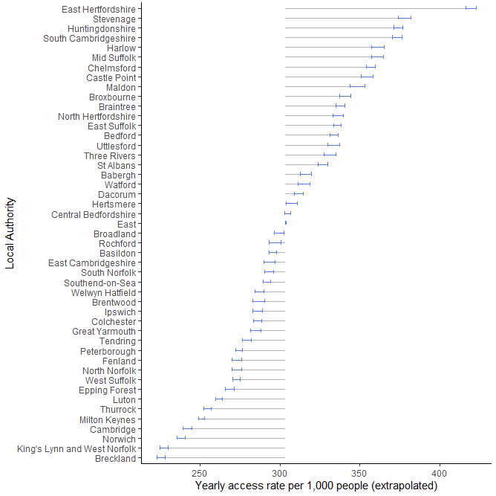
Crude Access rates using whole of East of England access as mean 2021 (Dec 2020-March2021)

Milton Keynes shows access rates that are lower than other areas in the East of England. Due to changes in national policy extrapolated dental access data is shown for 2021 (extrapolated Dec 2020-Mar 2021). Dental access rates per 1000 in MK was 250
Figure 2 – NHS Dentist access rates for towns and cities in the East of England NHS Region

Our witnesses were also united in stressing the importance of improving oral health, which means in practice brushing effectively twice a day with fluoride toothpaste, flossing, using a mouthwash, avoiding sugary sweets and snacks and going to see a dentist once a year or so for a check-up. There appears to be something of a consensus that it is those that do not look after their teeth, and only go to a dentist once they have accumulated several years of overdue dental work, that are overwhelming the NHS. Whilst this is probably true it does not move us forward. Fewer dentists, combined with existing low access rates in Milton Keynes, will not lead to an improvement in the population's oral health.

General Practice

The issues in general practice are very different from those in dentistry. Amongst the reasons for convening this task and finish group was the scores achieved by surgeries in the City in the periodic GP Patients Satisfaction Survey, however this survey is principally measuring patient perception of a limited range of measures. The areas where surgeries score lowest are normally those concerned with calling the surgery and getting an appointment to see a GP; once patients have seen a medical professional they are generally happy. For example, the Group visited Whaddon Healthcare in Bletchley, a surgery rated outstanding by the CQC and for very good reason. We found clinical and administrative staff dedicated to supporting their registered patients, considering their patients' health needs holistically and providing a host of core and non-core health services, and facilitating a range of opportunities and groups providing social and health related activities. However, in the 2022 GP Patient Satisfaction survey, 75% of Whaddon patients surveyed said that it was not easy to get an appointment, with only 25% saying that it was. On the other hand, 84% said that receptionists were helpful and similar numbers said that they were happy with the treatment received, and that they were properly listened to by the clinician.

There are twenty seven surgeries in Milton Keynes. Not all of them provide the same range of services for various reasons, which will include space, the business model and ambitions of the business and the structure of the business, but they are all rated good or above by the CQC. However, we see a similar pattern for many of them in the results of the Patient Satisfaction Survey, i.e. dissatisfaction in getting an appointment, but generally happy once the patient has been seen. There are some outliers, i.e. some surgeries do well in scores for appointments and some do less well in overall satisfaction.

There is certainly variability in the services provided by different surgeries. On the face of it there are mechanisms in place to monitor the performance of surgeries, including the independent oversight provided by Healthwatch MK. The ICB are candid that some surgeries are not performing as well as they would like them to be, and have invited councillors to open a dialogue with them if they have concerns about their local facilities. The ICB have recently assumed responsibility for GP surgeries (although to some extent this will have been in practice a continuation of what was already happening in the now defunct Clinical Commissioning Groups (CCG)) and play an active role in seeking to improve surgeries where there is clear room for improvement.

We were assured by the ICB that all surgeries now have IT systems in place that can make use of online services for patients to seek advice and guidance, request an appointment, request repeat prescriptions and so on. Some surgeries may not be using all available tools and some may only make them available on request. A more detailed consideration of the online facilities would be warranted, but the TFG has not had the time to undertake this.

What is clear, however, is that there is a lack of public understanding of the services offered by general practice, and how general practice works in the modern world. Members of the TFG are councillors, abreast of developments in their community and the City generally, but it is fair to say that most of us came to the evidence sessions thinking that a visit to the GP was a visit to a doctor, probably wearing a white coat, and that an appointment is made by calling the surgery at opening time and hoping that you can get through before the appointments run out. It turns out to be very different on the ground. General Practice is comprised of a wide range of professional, specialist clinical staff (figure 3) and many (if not most) patients will be better off being directly referred to one of those specialists rather than to the GP. Patients can seek advice from their surgeries online, order repeat prescriptions, consult with clinical specialists using telephone or video. They can go onto the NHS website to check where they are on a waiting list for secondary treatment. The simple fact is that most people do not seem to realise this and instead rely on the 'traditional' method of telephoning the surgery to seek an appointment with the GP. Whilst there is nothing wrong with this, particularly if for example the health complaint is something that does require immediate attention, it does make it difficult for the surgery to plan for the best use of its staff, and there are in fact much better ways to interact with the local surgery.

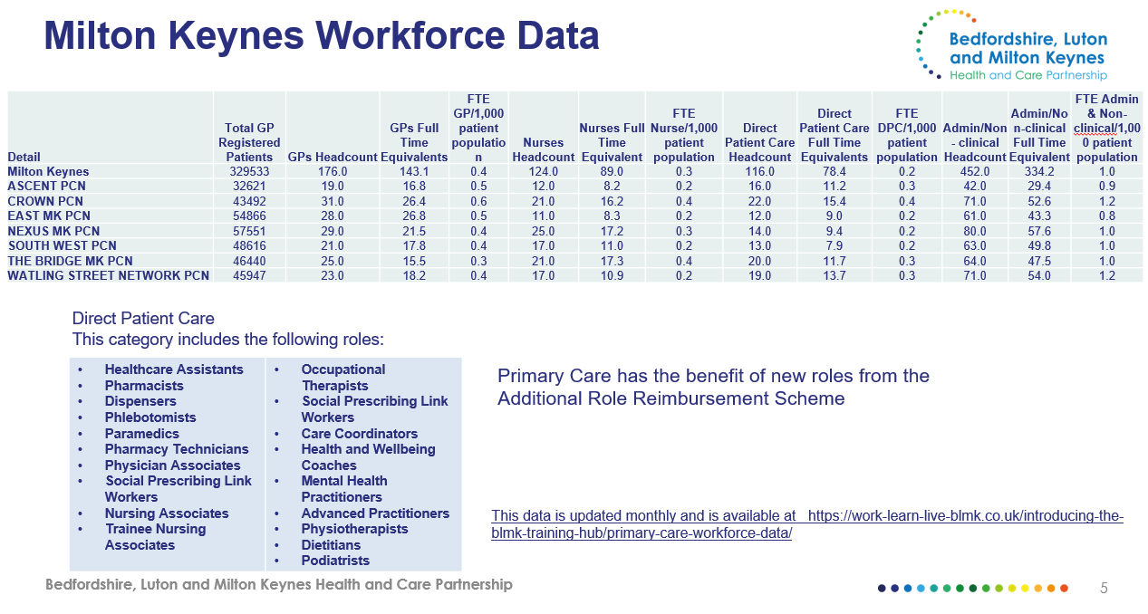
Figure 3 – Clinical and non-clinical workforce data for Milton Keynes Primary Care Networks

5. Thanks and Group Membership

The Group wishes to extend their gratitude to and acknowledge the contribution of the many people that have given up their time to meet with the group and to share their experience and expertise (listed in order of their appearance before the group).

Tracy Keech – Deputy Chief Executive Officer of Healthwatch Milton Keynes
David Barter – Head of Commissioning for NHS England
Jessica Bendon – Senior Dental Contract Manager for NHS England
Alexia Stenning – Associate Director Primary Care Commissioning and Transformation, Bedfordshire, Luton and Milton Keynes Integrated Care Board
Janine Welham – Senior Primary Care Development and Transformation Manager, Bedfordshire, Luton and Milton Keynes Integrated Care Board
The staff of Whaddon Health Centre
Naema Alam – Clinical Director, Whaddon Health Centre
Sarah Black – Vice Chair, Parents and Carers Alliance MK
Toni Fisher – Practice Business Manager, Whaddon Health Centre
Mr Resh Diu – Dentist
Dr Debbie Ganguli – Dentist

Membership of the Task and Finish Group

Councillor Amber McQuillan, Chair (Labour)
Councillor Liam Andrews (Conservative)
Councillor Marie Bradburn (Liberal Democrat)
Councillor Joe Hearnshaw (Conservative)
Councillor Shanika Mahendran (Labour)

Officer Support

Marimba Carr - Deputy Director of Public Health, Milton Keynes City Council
Andrew Clayton - Overview and Scrutiny Officer, Milton Keynes City Council

ijipwa
Overview and Scrutiny
Democratic Services
Milton Keynes City Council
Civic Offices
1 Saxon Gate East
Central Milton Keynes
MK9 3EJ

democracy@milton-keynes.gov.uk

Milton Keynes City Council (milton-keynes.gov.uk)

