Health and Wellbeing Award
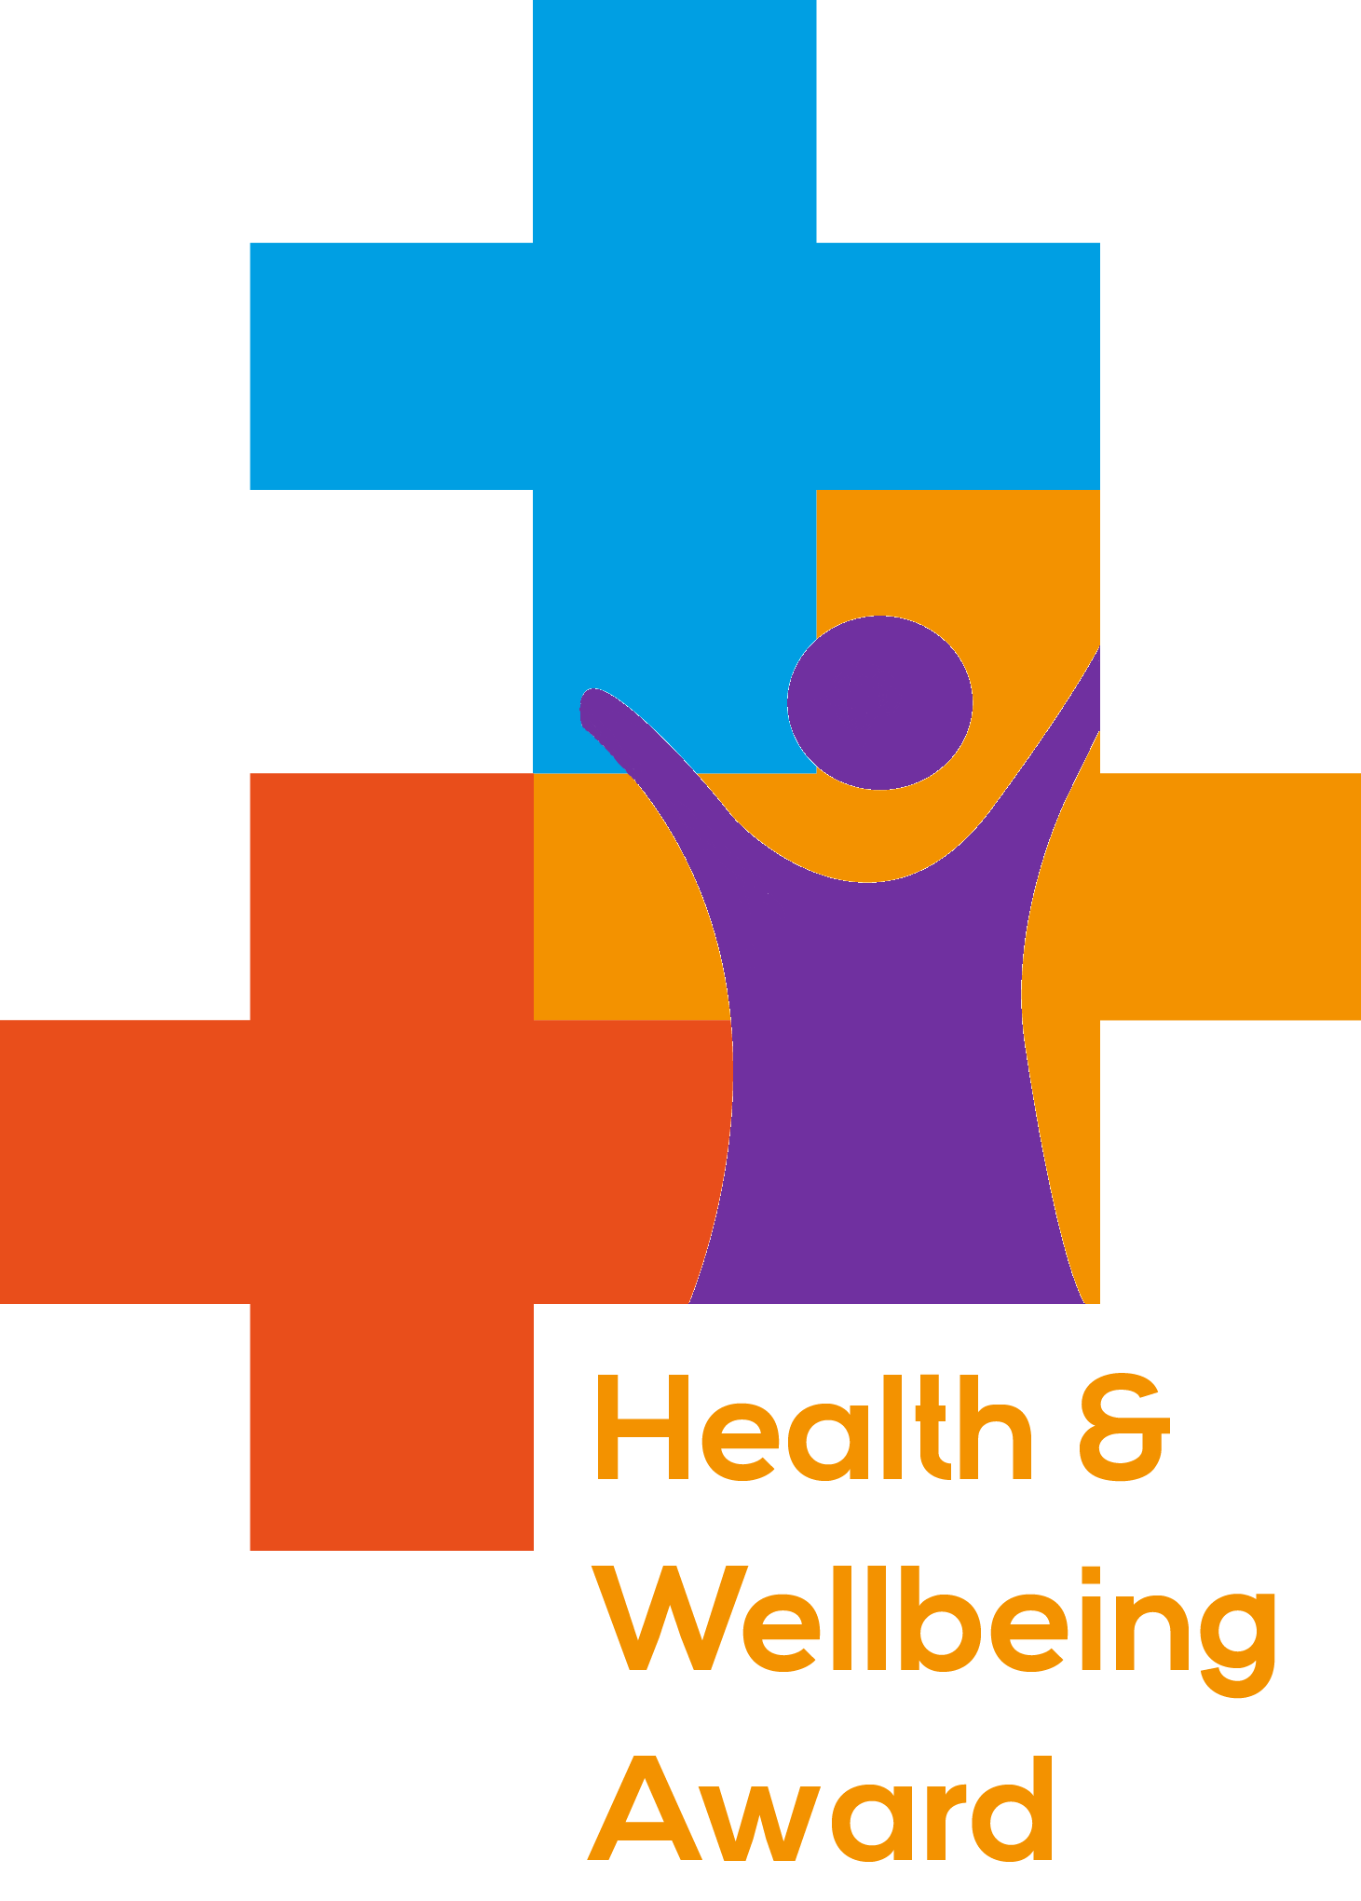
Name of Setting/Centre: XXXXXXXXXXXXXXXXXXXXXXXX
Name of contact: XXXXXXXXXXXXXXXXXXXXXXXX Date: 00/00/0000
When completing this audit think about:
Examples of practice – what are you doing within your setting to support this?
Examples of impact – have you seen positive changes? How do you know this has happened? Do you have evidence to show this has happened?
Examples of future plans – what can you develop? Have you identified any gaps? What are the timescales for these plans?
Date of Accreditation (Internal use only): 00/00/0000

Healthy Eating Criteria
1. The setting has a healthy eating policy which supports breastfeeding. |  |  |  | Date of completion
Minimum evidence:  A food policy which takes a whole setting approach to healthy eating, which is actively implemented and communicated to staff and users. | Practice:  - XX  - XX  - XX | Impact:  - XX  - XX | Future plans:  - XX  - XX
2. The setting provides positive healthy eating messages. |  |  |  | Date of completion
Minimum evidence:  Positive messages about oral health and healthy weight are provided as appropriate. | Practice:  - XX  - XX  - XX | Impact:  - XX  - XX | Future plans:  - XX  - XX
3. Children are provided with positive food experiences at every opportunity including incorporating health food into the wider curriculum (numeracy/literacy). |  |  |  | Date of completion
Minimum evidence:  The setting provides healthy food and drink to children & young people by:  - adhering to the school food standards*  - a positive eating experience  - Supporting waste reduction and sustainable food and drink.  *Only applicable to services delivering breakfast clubs / after school clubs linked to a school. | Practice:  - XX  - XX  - XX | Impact:  - XX  - XX | Future plans:  - XX  - XX
4. The whole setting is informed, engaged and actively supports the healthy eating element of the Award |  |  |  | Date of completion
Minimum evidence:  Children/ young people, parents, staff and partners are consulted on and informed about the settings approach to healthy eating. | Practice:  - XX  - XX  - XX | Impact:  - XX  - XX | Future plans:  - XX  - XX

Physical Activity Criteria
1. The setting has a physical activity policy that supports active travel |  |  |  | Date of completion
Minimum evidence:  A policy which takes a whole setting approach to physical activity, which is actively implemented and communicated to staff, children, young people and parents. | Practice:  - XX  - XX  - XX | Impact:  - XX  - XX | Future plans:  - XX  - XX
2. Children / young people are provided with a curriculum where physical activity is embedded within it. |  |  |  | Date of completion
Minimum evidence:  The setting contributes to the additional 30 minutes every day of moderate to vigorous physical activity outside of school. | Practice:  - XX  - XX  - XX | Impact:  - XX  - XX | Future plans:  - XX  - XX
3. Parents and children/ young people are encouraged to engage with active travel |  |  |  | Date of completion
Minimum evidence:  The setting provides a range of options for families to travel actively to the setting. | Practice:  - XX  - XX  - XX | Impact:  - XX  - XX | Future plans:  - XX  - XX
4. The whole setting is informed, engaged and actively supports the physical activity element of the Award |  |  |  | Date of completion
Minimum evidence:  - Children / young people, parents, staff and partners are consulted on and informed about the setting’s approach to physical activity.  - Families are encouraged to be physically active outside of the setting (providing at least an additional 30 minutes every day of activity outside of school). | Practice:  - XX  - XX  - XX | Impact:  - XX  - XX | Future plans:  - XX  - XX

Lifestyle Influences Criteria
This section includes all the wider health issues that impact families. There are a number of key elements relating to health and wellbeing, including sex and relationships, smoking, drugs and alcohol and safeguarding. Locally you may identify influences specific to your community such as housing, young carers, bereavement, FGM etc (NB some elements for MH are covered here and in the section below).
1. The setting has a set of comprehensive policies relating to all aspects of health and wellbeing. |  |  |  | Date of completion
Minimum evidence:  Policies take a whole setting approach and are actively implemented and communicated to children and young people, parents and staff, polices include (but are not exclusive to):  - Anti-bullying  - Smoking  - Safeguarding  - Inclusion / SEN  - Behaviour and discipline  - Health and wellbeing* | Practice:  - XX  - XX  - XX | Impact:  - XX  - XX | Future plans:  - XX  - XX
2. The setting fully supports positive Emotional Health and Wellbeing of the whole community. |  |  |  | Date of completion
Minimum evidence:  - The setting actively supports vulnerable children and young people and families, including young carers, SEN, LGBTQIA+, children at risk (child protection, looked after children), children with special circumstances (bereavement, divorce, separation, poverty) and English as an additional language.  - The setting addresses emotional health and wellbeing, by addressing and building self-esteem and confidence, and celebrating achievements. | Practice:  - XX  - XX  - XX | Impact:  - XX  - XX | Future plans:  - XX  - XX
3. The setting provides positive messages and experiences of a variety of lifestyle factors. |  |  |  | Date of completion
Minimum evidence:  Positive messages about a variety of lifestyle factors are provided throughout the setting, including:  - Smoking, drugs and alcohol.  - Hygiene.  - Personal safety such as fire, internet, sun, lifesaving and anti-bullying.  - Relationships and sex education. | Practice:  - XX  - XX  - XX | Impact:  - XX  - XX | Future plans:  - XX  - XX
4. Staff have good knowledge about specialist services which impact on the emotional health and well-being of the child. |  |  |  | Date of completion
Minimum evidence:  Staff support individuals in making positive changes to their physical and mental health and wellbeing by having the competence and confidence to deliver healthy lifestyle messages.  *Also, please see separate section on positive MH & emotional wellbeing below. | Practice:  - XX  - XX  - XX | Impact:  - XX  - XX | Future plans:  - XX  - XX

Positive Mental Health & Emotional wellbeing (MH & EWb) Criteria
This section includes a whole system approach to supporting positive MH & EWb within the setting for children, young people and families and staff. There are a number of key elements relating to this including: Leadership & Management, Ethos and Environment, Curriculum, teaching and learning, Voice of the children/young people, staff development, health and wellbeing, identifying need and monitoring impact, working with parents/families/carers and targeted support and appropriate referrals. (NB Protective factors above and this section interlink)
- The setting has leadership and management with strong knowledge and evidence of positive mental health ethos and an  environment to support positive MH & EWb. |  |  |  | Date of completion
Minimum evidence:  The setting provides strong leadership which creates a positive environment that promotes health and wellbeing.  The setting actively promotes and embeds positive health and wellbeing*  The setting works hard to engage the whole community in wellbeing activities*  *Wellbeing policies are embedded within lifestyle factors along with supporting vulnerable CYP and embedding community elements | Practice:  - XX  - XX  - XX | Impact:  - XX  XX | Future plans:  - XX  - XX
2.Teaching and learning and children and young people’s voice |  |  |  | Date of completion
Minimum evidence:  The setting has good provision to support positive MH and emotional wellbeing and includes the children and young person’s voice, including those who are less vocal and visible  The setting ensures that planning teaching and learning is in line with best practice  Children and young people have opportunities to develop responsibility, build confidence, develop resilience and self-esteem | Practice:  - XX  - XX  - XX | Impact:  - XX  - XX | Future plans:  - XX  - XX
3. Staff development, Health and Wellbeing; Identifying need and monitoring impact |  |  |  | Date of completion
Minimum evidence:  Staff have up to date training and development on positive mental health and wellbeing  Staff develop and maintain a healthy physical and mental lifestyle to enable them to cope in their role, and to be positive role models  Setting identifies children and young people facing challenging circumstances and offers appropriate signposting and support. | Practice:  - XX  - XX  - XX | Impact:  - XX  - XX | Future plans:  - XX  - XX
4. Working with Parents, families and carers and targeted support and appropriate referrals |  |  |  | Date of completion
Minimum evidence:  The setting promotes and signposts and refers parents/carers to appropriate MH & Ewb services.  The setting report on the progress and achievement of CYP in areas that are relevant to their positive mental health and wellbeing  The setting regularly celebrates the achievements of positive mental health and emotional wellbeing | Practice:  - XX  - XX  - XX | Impact:  - XX  - XX | Future plans:  - XX  - XX

