Story telling as a therapeutic approach with children

**Therapeutic Stories**

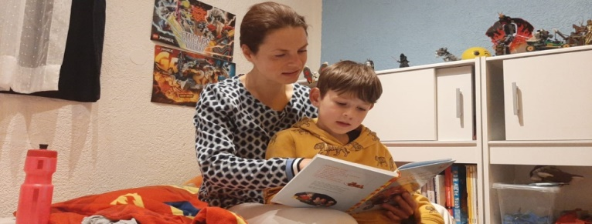

**What are therapeutic stories?**

Firmly grounded in the psychological literature, therapeutic stories use metaphor and story to make indirect expressions of a child’s difficult feelings. They speak to a child about how a coping mechanism they are using is not helpful and what this is costing them. The stories present hope in the form of healthier coping mechanisms and ways of being.

**Who are therapeutic stories for?**

They are useful for children who are ‘emotionally vulnerable’ or ‘hard to reach’. Often these children present with unhelpful coping mechanisms and/or challenging behaviours.

**Why use therapeutic stories?**

Children respond to the world of imagination. Stories offer opportunities to explore who they are and what they feel through the protected world of the imaginary. As children’s abstract reasoning is not fully developed yet the stories offer means to express internal worlds, such as anxiety or shame, through story metaphors without making themselves vulnerable.

**Background**

**Therapeutic Stories Training**

The training was offered to a nurture group embedded in a local primary school. The group is run by a small team of teachers and teaching assistants and attended by a group of children with social and emotional needs. Contents were delivered across two twilight sessions by a Trainee Educational Psychologist and two Psychology Assistants. The sessions focused on:

* Understanding the principles underlying the use of therapeutic stories with children
* Who therapeutic stories could be used for
* Understanding how to read a therapeutic story to a child and how to write one
* Considering examples of therapeutic stories and joint writing of a story tailored to the needs of a child attending the nurture group



Feedback was overwhelmingly positive in response to the realisation that story telling can be a natural and gentle yet powerful ‘intervention strategy’ aimed at regulating behaviour. As staff collaborated on creating their own story for one of their children, the process not only enhanced team cohesion but creating the story also deepened their understanding and empathy for the child and left them excited about the possibilities of using stories in their nurture group.

**Contact the EPS if you would like more information**