Academic Year 2022-2023
Dear Parent/Carer,

MK Primary School Explorers Competition- Summer Holidays 2023

What?
Your family is invited to take part in the Milton Keynes School Explorers competition from July 22nd to September 4th using the FREE Love Exploring App. The app provides free, educational and fun games to play in and around Milton Keynes.

Take your family on a dinosaur safari or hunt the mega mini beasts and earn points for your school as you increase your steps and answer the questions. There are lots of games and trails to choose from across MK parks so don’t miss out!

The more you play – the more points you earn for your school to keep them at the top of the leader board!
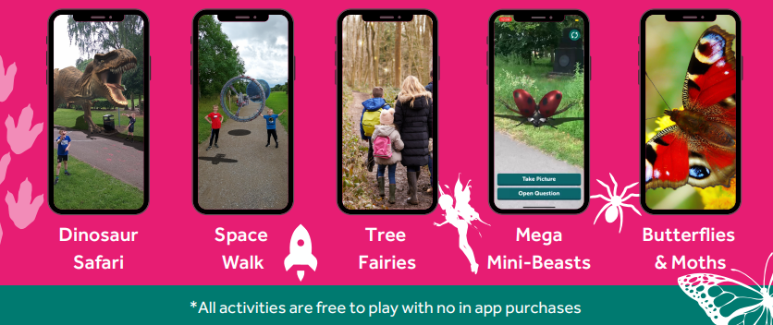

Why?
This is an opportunity for families to get active together over the summer break, explore MK’s Parks and learn a few fun facts along the way. The App has something for everyone. There are 69 augmented reality games in addition to a selection of guided trails from the Sculpture Trail to the ROCLA Art tour and more.

Get involved?
To play you’ll need to download the FREE Love Exploring App from your mobile phone app store. You can find this by searching for ‘Love Exploring’ or scanning the QR code.

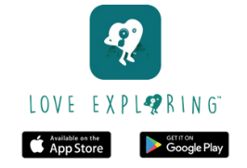
Then link your user account to your child's Primary School and earn points when you play.

It’s easy to link your user account to your Childs primary school:
- In the app select the menu icon in the top right-hand corner
- Choose ‘school explorers’
- Choose ‘link to my account’
- Choose Milton Keynes and then the name of your Primary School

For more information visit
https://www.milton-keynes.gov.uk/health-and-wellbeing-hub/love-exploring

Yours Sincerely,

